|  |  |
| --- | --- |
| **Text Based Discussion and Writing (Read Aloud or Shared Reading)** | |
| *Core Action 3A. The teacher keeps all students persevering with challenging tasks.*  *Students habitually display persistence with challenging tasks, particularly when providing textual evidence to support answers and responses, both orally and in writing.*  *Core Action 3B. The teacher encourages reasoning and problem solving by posing challenging questions and tasks that offer opportunities for productive struggle.*  *Students persevere in solving questions and tasks in the face of initial difficulty.* | |
| Possible Sequence of Teacher Moves  *In grades K/1, and sometimes 2, these moves will be done with teacher read aloud. In 3-8, these moves will be done with a shared text.* | |
| 1. Cut pre-reading activities. | Select academic vocabulary words that are central to the meaning of the text AND ones that allow students to determine the meaning from context.  Ask if anyone knows the meaning of the selected word(s) and how.  Eliminate pre-teaching/modeling strategies—instead, ask “what did you do to understand your reading” after students have listened/read. |
| 1. Pose text specific questions with opportunities for everybody to engage in the work before accepting answers. | “Turn and talk” or “turn to your table groups.”  “Everybody write the answer to this question.”  “Jot 1-2 words in the margin/ on a post-it/ on your dry erase board that answers the question.” |
| 1. Flag possible text based challenges, with students tackling those rather than teacher modeling. | “Turn and talk:  tell your partner what’s going on here.”  “Reread this to yourself, underline key words that tell you what’s happening here.”  “Re-read this to yourself, circle words you don’t know or ideas you don’t understand.”  “Read this part with your partner and discuss what you think it is about.” |
| 1. Have students flag the challenges in the text, rather than the teacher.   *Note- when possible, if students are still experiencing challenges, have other students share rather than the teacher.* | Have students point out the challenges, work in partners to try to problem solve, ask for additional support after X number of “tries” have failed. |

|  |  |
| --- | --- |
| **Foundational Reading or Fluency (Guided Reading or Shared Reading)** | |
| *Core Action 3C. The teacher guides students to read with purpose and understanding by making frequent connections between acquisition of foundational skills and making meaning from reading.*  *Students demonstrate comprehension while developing foundational skills in reading.*  *Core Action 3E. The teacher focuses on explicitly and systematically strengthening students’ reading foundational skills.*  *Students demonstrate use of language conventions and decoding skills, activating such strategies as needed to read, write, and speak with grade-level fluency and skill.* | |
| Possible Sequence of Teacher Moves  *For Foundational Skills, Fluency and/or Guided Reading Lessons, as appropriate* | |
| 1. Cut pre-reading activities or modeling | Select academic vocabulary words that are central to the meaning of the text AND ones that allow students to determine the meaning from context.  Ask if anyone knows the meaning of the selected word(s) and how.  Eliminate pre-teaching/modeling strategies—instead, after reading ask “How did you figure that out?” |
| 1. Involve Student Voices | Independent reading:   * “Read to yourself and stop at page 3.” * “Read aloud to your reading buddy, taking turns with each sentence.”   Multiple students read with teacher support:   * Echo read with struggling readers (teacher reads a section, students repeat same section) * Choral reading (we all read together)   Allow different students to read aloud parts  Allow time for students to share strategies or noticings around word solving/fluency post-reading (“What did you try? Did it work? Did anyone try something different?”) |
| 1. Student Self-Assessment | Have students self-monitor and determine if they are comprehending a text or task.  Ask “What made this text challenging?”  Ask “Did you get stuck at any point? What did you do? “Ask “What are you working on?” |
| 1. Use open prompts before intervening with student mistakes | Provide ample wait time for students to problem solve  When student reads challenging word, correctly or incorrectly, ask them “Is that right? How do you know?”  Ask “What will you try?” or “What can you do next?” or “Try that again.”  Ask “What do you think is making this difficult?” |
| *If working on comprehension with small groups, you may want to add strategies from the 3-8 grade working with complex text strategy sheet.* | |

|  |  |
| --- | --- |
| **Reading Complex Text (3-8) (Shared Reading)**  ***Could be used along with “Text Based Discussion and Writing”*** | |
| ***Core Action 3B****. The teacher encourages reasoning and problem solving by posing challenging questions and tasks that offer opportunities for productive struggle.*  *Students persevere in solving questions and tasks in the face of initial difficulty.*  ***Core Action 3D.*** *The teacher demonstrates awareness and appropriate action regarding the variations present in student progress toward reading independently.*  *When appropriate, students demonstrate progress toward independence in reading and writing.* | |
| Possible Sequence of Teacher Moves | |
| 1. Alternate between read aloud, multiple student voices, and independent reading. (strategically considering student reading level) | Independent reading:   * “Read to yourself and stop at page 3.” * “Read aloud to your reading buddy, taking turns with each paragraph.”   Multiple students read with teacher support:   * Echo read with struggling readers (teacher reads a section, students repeat same section) * Choral reading (we all read together) * Read the full text while students follow along (students must have copies of the texts or text is projected) * Allow different students to read aloud parts |
| 1. Address challenging portions of text through text specific questions or targeted rea-reading. | “Turn and talk:  tell your partner what’s going on here.”  “Everybody write the answer to this question”  “Reread this to yourself, underline key words that tell you what’s happening here.”  “Re-read this to yourself, circle words you don’t know or ideas you don’t understand.”  “Read this part with your partner and discuss what you think it is about.”  Purposeful re-reads aloud with struggling readers. |
| 1. Facilitate student-led discussion, intervening to pace the lesson or direct students based on misconceptions. | “Let’s hear from 3 more people and decide if we agree.”  “What do you all think?  Agree, disagree, add on?”  “Can anyone re-read a statement that proves or disproves that point” |
| 1. Clarify misunderstandings and support solutions.   *Note- when possible, if students are still experiencing challenges, have other students share rather than the teacher.* | Have students summarize key points.  Have students vote, poll, or offer why they’ve changed their minds.  Have students summarize confusion.  *Note- use teacher discretion and intervene strategically to help students move past their confusions as needed.* |

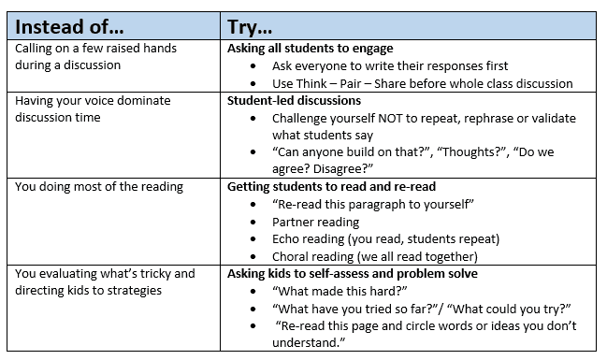

From: www.achievethecore.org